Current Activities & Acquisitions
During the last quarter we have received donations of a PC-XT with mono monitor and a daisy wheel printer, as well as two 'Electronic Golf Ball Typewriters', an ET50 and ET95, the latter complete with a 5.1/4" diskette drive, a rare find. The 50 is somewhat gummed up and will need degreasing and re-lubrication, while the 95 is mechanically in good order, but has an intermittent power supply problem - very intermittently it works!

After an appeal on the Yahoo Golf Ball Typewriter forum, Lukas Tschudi, who runs a typewriter shop in Switzerland (called "SchreIBMaschinen") scanned his entire collection of service manuals for us, and has subsequently stripped the electronics from a scrap 85, which are on the way to us now.

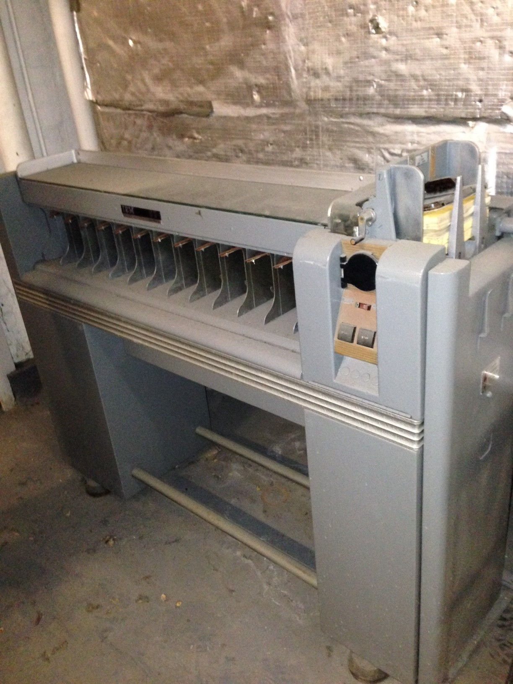
Following the closure of Buchan House in Edinburgh, we have been promised an 082 card sorter, which is supposed to be in full working order. It is being shipped to Greenock for safe keeping until transport can be arranged.

Last month Peter purchased a Selectric Composer on eBay for 99p, and collected it from Weymouth. Sadly the seller had binned the three boxes of type elements and user manual before collection. As usual it will require degreasing and lubrication, but otherwise looks in good shape.

We have also just received another 1052 keyboardless golf ball printer as used as a console printer on S/360.

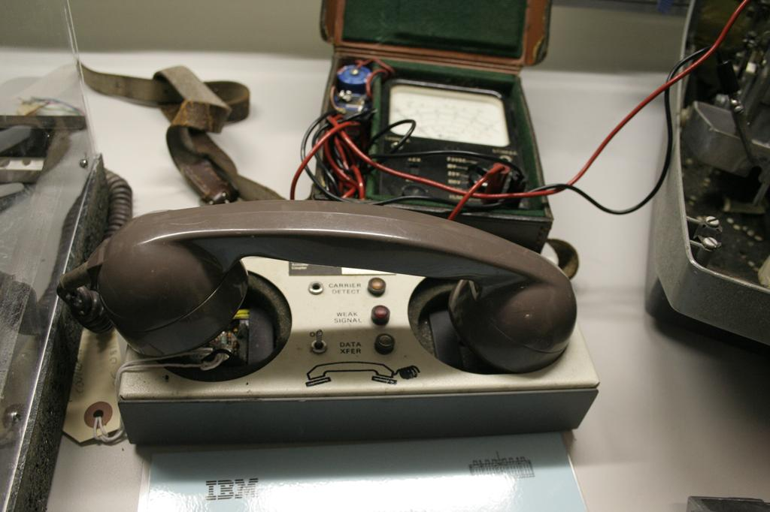
Dik Leatherdale suggested we ask the Amberley museum if they have a spare telephone handset for our acoustic coupler. They have kindly donated one, although it is physically a bit bigger than the coupler's pads. Mark subsequently brought in an old US telephone, and the handset fits.

Terry has been busy trying to get our several AS/400s working, with some success. We are trying to obtain a copy of CICS/400 as a step towards a CICS exhibit. Oh! for a 2984 Lloyds Cashpoint...

We have marked the 50th anniversary of S/360 with a small display of artefacts from this system, including a TROS unit and SLT modules and cards.

